**Lab 1 Activity 10 - Finalizing the Document**

**Objective** – Finalize the document using spell check, grammar check, and document properties.

1. Run the spell and grammar check.
2. Add document properties (title, author, keywords).
3. Protect the document with a password.
4. Inspect the document for hidden metadata before sharing.

**____________________________________________________________________________________**

**Solutions:**

**Task 1:**

To run a spell check:

* Go to the “Review” tab at the top of the screen.
* In the Proofing group, click Spelling & Grammar.
* Word will scan the document for spelling and grammar errors. If it finds any, it will display a dialog box where you can choose to Ignore, Ignore All, Change, or Change All depending on the issue.

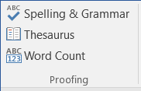

**Task 2:**

To see document properties:

* Go to “File” tab.
* Go to “info” section from the menu list.
* Add or view properties.

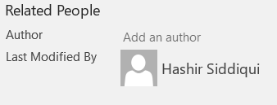

**Task 4:**

To see meta data of the document:

* Select the document.
* Right click on it. Go to properties.
* Click the details tab.
* You will see the properties there.

